Door Survey Sheet
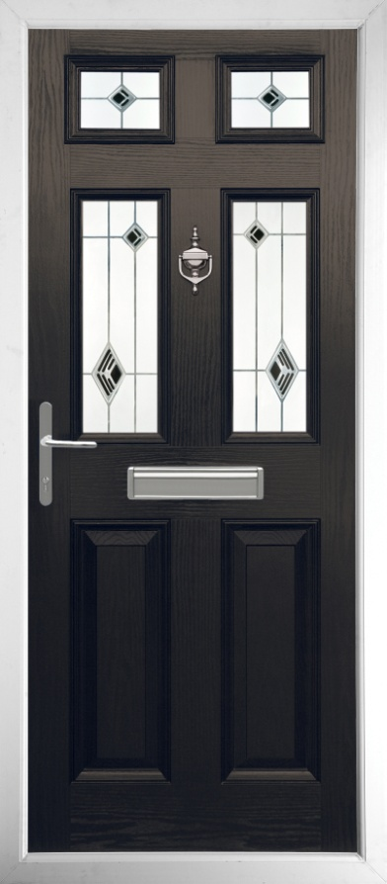
A

B

C

D E F
 | Dimension (mm) | Description
A |  | Top width
B |  | Middle width
C |  | Bottom width
D |  | Left height
E |  | Middle Height
F |  | Right height

Smallest Width in mm minus 10 mm .................................mm
Smallest height in mm minus 10 mm .................................mm

